# Applying methodology for examining potential technology breakthroughs for mitigating electric sector emissions to offshore wind

## Abstract

Offshore wind is an established technology in Europe, as the second largest source of power generation with over 189 GW of installed capacity[1], but it has not yet gained market share in the United States (US). There is, however, increasing interest in and action supporting offshore wind development from many coastal states, predominantly along the Atlantic coast. The offshore wind resources in the US are vast, with an estimated 10,800 GW of resource potential, 2,058 GW of which are technically feasible for development.[2] *** need to take out the citations from the abstract, maybe use general terms and put the specifics back in the introduction *** To date, only 30 MW of this potential has been realized. In late 2016, the 5 turbine Block Island Wind Farm began commercial operation as the first offshore wind farm in the US. With the potential for growth in the offshore industry in the US in mind, this research seeks to explore energy futures that include offshore wind and the resulting changes to the energy mix and grid emissions. If offshore wind grows in the US, as it seems likely to, it will displace existing generation assets, and depending on which assets those are, the resulting emissions from the power sector. This paper explores combinations of cost curves and carbon mitigation scenarios to measure the changes in the energy mix and quantify offshore wind’s impact on the resulting emissions. The results could inform planning geared towards grid emission reductions and the effectiveness of offshore wind to emission reduction goals.

For this analysis, an energy system modeling approach is used to generate and explore potential energy futures. The approach uses the Integrated MARKAL-EFOM System (TIMES) energy system model and a database representation of the U.S. energy system called the EPAUS9rT, applying a nested parametric sensitivity analysis to represent potential futures. Combinations of carbon mitigation stringencies and offshore wind cost curves created vastly different energy futures with comparably different emissions profiles.

This sensitivity analysis allows us to explore the benefits of offshore wind as an energy source within the U.S. as it relates to air quality and GHG emissions reductions. We look at results both nationally and regionally, analyzing the differences in regional adoption of off-shore wind and how access to this technology provides a broader range of emission reduction options for the power sector. (Add a brief summary of results)

## Introduction

Offshore wind is a renewable energy resource available over coastal and great lake waters. Its low variability and uncertainty paired with its proximity to large population centers makes it a prime candidate for electricity production. In the US, approximately 40% of the population lives on the coast, and this population has grown 40% since 1970.[3] This means electricity consumption is growing and there is less area available for development. More so, the area that is available is expensive due to availability constraints. It is, nevertheless, a relatively expensive technology. Many factors contribute to the high price, the most impactful being complex installation that requires highly-skilled instrumentation and labor at sea. Distance to shore and depth of water add to these costs. Lastly, the electricity produced must make its way to shore through seaworthy transmission lines.

Twenty-five coastal or great lakes states and Washington D.C. have instituted Renewable Portfolio Standards or Goals (RPS)[4] and twenty have set greenhouse gas (GHG) emissions targets.[5] Both types of policies incentivize the buildout of renewable and emissions-free generation resources, for which offshore wind qualifies. These policies have already begun to change the energy landscape. Policies paired with declining costs for terrestrial wind and solar led renewables to account for 17% of electricity generation in the US in 2018[6], an increase of 5% from 2017.[7] It is unclear exactly how offshore wind will fit into this changing landscape, and what impact it will have.

With the growth of the offshore industry in the US in mind, this research explores potential energy futures that include offshore wind and analyzes the resulting changes to the electric sector technology mix and associated emissions. Two drivers for offshore wind development are explored: (1) offshore wind costs and (2) carbon mitigation stringency.

(1) Offshore Wind Costs: Supply chains are not yet developed in the US for offshore wind and the development and transmission costs associated with sea-based projects are high. This results in a high cost for offshore wind as compared to other technologies. However, there is a great deal of potential for a declining cost curve for offshore wind. As capacity expansion in the power sector is highly sensitive to cost, this measure captures one of the main barriers to offshore wind deployment.

(2) Carbon Mitigation Stringency: Electricity generation produces several emissions, including, but not limited to sulfur dioxide (SO2), nitrogen oxides (NOx), fine particulate matter (PM 2.5), methane (CH4), and carbon dioxide (CO2). These emissions vary in their environmental and health impacts, as well as their cost of mitigation. Federal programs already exist for the mitigation of SO2 and NOx from power sector, but not for CO2. This measure accounts for air-quality and environmental health regulations that would favor non-emitting sources of power generation beyond what already exists. It also helps to encapsulate the upward trend in states with GHG emissions targets.

An energy system modeling approach is used to generate and explore these potential energy futures. The methodology developed in Loughlin et al. (2012) for assessing the breakthrough potential of emerging technologies for emissions mitigation was applied to offshore wind. The Loughlin et al. methodology was designed to evaluate the potential of energy technology developments to yield a breakthrough in achieving GHG mitigation goals. It was applied more broadly in this research to evaluate the changes that offshore wind would elicit in the energy mix and grid emissions.

The approach involves a nested parametric sensitivity analysis using the TIMES energy system model with the EPAUS9rT, a database representation of the U.S. energy system. Combinations of carbon mitigation stringencies and offshore wind cost curves create vastly different energy futures with comparably different emissions profiles. The analysis allows us to analyze the factors associated with the implementation of offshore wind and the benefits to system emissions associated with an increase in wind power.

## Background

Offshore wind in Europe has reached cost competitiveness with many other technologies, though terrestrial wind and solar PV are still less expensive. Technically speaking, it is still at a relatively early stage of development, even in Europe, and prices are expected to fall further as the technology advances.[8] In 2017 the National Renewable Energy Laboratory (NREL) published a study assessing the economic potential of offshore wind in the US projected a decline of approximately 50% in the levelized cost of electricity (LCOE) of offshore wind, both shallow and deep, by 2030.[9] Supply chain and infrastructure advancement are key to these price declines, but the largest contributor has been the growth in the capacity of turbines. In 2016 the Block Island Wind Farm installed 6 MW turbines, standing at a height of 590 ft. In 2019, the newest and largest turbine design, the GE Halide X, has a doubled to a 12 MW capacity. It stands at 863 ft and has a 63% capacity factor, which is five to seven percent higher than the industry standard.[10]

Steep LCOE decline has precedent in the US. Since 2009 the LCOE of solar PV and terrestrial wind have declined 88% and 69%, respectively.[11] These declines reflect both technological advancement and economies of scale for these technologies. Offshore wind expects to benefit from these factors, enhanced by industry and state government interest in investing in the technology. However, offshore wind still stands as one of the most expensive generation resources available in the US (EIA LCOE Table).

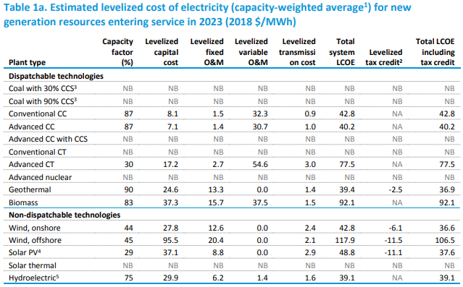[12]

CREATE YOUR OWN TABLE, referencing this table, but putting in only the important and available data.

Despite the high price of offshore wind in the US, many states are taking steps towards incentivizing and implementing the technology. Recent state advancements in the offshore wind field supporting offshore wind projects and supply chain include[13]:

* Massachusetts: 2016 law requiring procurement of 1,600 MW of offshore wind by 2027
* New York: 2017 Governor commitment to develop up to 2.4 GW of offshore wind by 2030; 2018 solicitation of at least 800 MW in two RFPs; $15 million investment to train for offshore wind jobs and develop port infrastructure
* New Jersey: 2018 law outlining target to develop 3,500 MW of offshore wind by 2030, the first 1,1000 MW of which have just been won by Orstead[14]
* Maryland: 2013 Offshore Wind Energy Act developed Offshore Wind Renewable Energy Credits (ORECs), which can be applied to the state’s renewable portfolio standard (RPS)
* Connecticut: 2018 Connecticut Department of Energy and Environmental Protection generation-based RFP for renewable energy, including offshore wind; $15 million investment to revitalize a shipping pier
* Rhode Island: 2018 competitive procurement for 400 MW of offshore wind, in collaboration with Massachusetts
* Virginia: 2018 submission of plans for the 12 MW Coastal Virginia Offshore Wind Project (CVOWP); 2018 order from Siemens Gamesa for two 6-MW turbines for CVOWP

INCLUDE a literature review of analyses of wind penetration in the U.S.

The large market in the US is at a tipping point, with a project pipeline of 25,434 MW of offshore wind energy as of June 2018.[15] Specific projects account for 3,892 MW of that capacity and the remaining 21,542 MW are comprised of undeveloped lease area. Of the project-based capacity, 2,000 MW is expected to be built and online by 2023. The US Bureau of Ocean Energy Management (BOEM), the agency responsible for offshore wind leasing areas, announced in June of 2019 that it would publish a “request for competitive interest” to build a transmission line for offshore wind off the coasts of New York and New Jersey.[16] A planned transmission system for offshore wind would promote long-term success and interest in the offshore wind market.

## Energy system modeling with TIMES

The TIMES model and EPAUS9rT energy system database, together, provide a comprehensive look at the US energy system. The EPA’s Office of Research and Development has worked to develop the TIMES-EPAUS9rT model to investigate energy system futures that optimize for lowest cost over all economic sectors. This allows the use of one model for all sectors instead of a piecemeal approach.

The TIMES ~~and MARKAL models are both~~ is developed by the Energy Technology Systems Analysis Program (ETSAP), one of the longest running programs at the International Energy Agency (IEA).[17] ~~While both models share a similar modeling paradigm, the TIMES model includes some notable additions: (1) commodity related variables and (2) realistic investment cost payments.~~ TIMES includes a wide range of commodity-related variables such as total production, total consumption, and process flows. Additionally, TIMES is ~~more accurately and dynamically~~ able to allocate costs investment timelines. ~~For example, large investments are paid in yearly increments over the construction time and payment of the increments are spread out over the economic life of the product. Small processes, on the other hand, are assumed to expand capacity at regular intervals with investments occuring at those intervals instead of in one lump sum. These additions, as well as others, allow for more flexibility in the TIMES model.~~

*** Look at carol’s paper(?) describing the epaus9rT database and TIMES

The TIMES model is used for investment and operation decision support, it uses a bottom up approach, temporal resolution is multiple years with user defined time slices within a year, modelling horizon is long turn[18]

Long-term energy system optimization model (ESOM)[19]

The TIMES model is a Linear Program formulated using the modeling language GAMS that maximizes system surplus by minimizing system costs. This formulation is called the *total system cost*. The TIMES objective is to minimize the total *cost* of the system, augmented by the *cost* of lost demand. All cost elements are discounted to a user-selected year. The current EPAUS9rT database and its TIMES implementation uses 2010 as the base year.[20]

Where:

* *NPV* is the net present value of the total cost for all regions (the TIMES objective function);
* *ANNCOST(r,y)* is the total annual cost in region *r* and year *y*;
* *dr,y* is the general discount rate;
* *REFYR* is the reference year for discounting;
* *YEARS* is the set of years for which there are costs, including all years in the horizon, plus past years (before the initial period) if the costs have been defined for past investments, plus a number of years after EOH where some investments and dismantling costs are still being incurred, as well as the Salvage Value; and
* *R* is the set of regions in the area of study.

Explain that the EPAUS9rT is regionally represented (with 9 regions) based on the U.S. census divisions. Offshore wind’s representation in this model accounts for the geographic and economic variability of the resource. The offshore wind resources within the model span every census region except for Region 8 (Mountain West), due to no offshore resources being directly accessible from this territory. For each of the remaining 8 regions, the model represents technologies for offshore wind spanning the following characteristics: water depth (shallow and deep), wind classes, and cost classes. A discount rate for new capacity of 0.10 was applied for all offshore wind technologies. Capacity factor was set to vary by time of day, season, technology, and region. For each offshore wind installation, a lifetime of 30 years was assumed.

***talk about the range, aka ranges from a high of x in region x to a los of x in region x***

***talk about what the classes, cost categories, shallow/deep are***

***shallow and deep don’t necessarily refer to floating vs fixed. Deep is more expensive but the technology used for those turbines is not specified***

The model sets a capacity bound for type of offshore wind in each region based on technical feasibility. What is not considered in the model is the practical timeframe in which all the available offshore wind development area will become available. BOEM, an agency within the US Department of the Interior, must assess outer continental shelf areas for leasing potential before they may be developed.

All scenarios constructed and evaluated in the TIMES model ran from 2010 to 2050.

Cost curves for offshore wind were constructed to linearly decline from 2015 to 2035 by a percentage of current costs. Capital expenditure (CAPEX) was back-calculated from LCOE’s presented in the Energy Information Administration’s (EIA) Annual Energy Outlook 2018 (AEO). The baseline cost reduction scenario assumes a 20% cost decrease, as is expected through normal technological advancement and “learning”. Five additional cost curves were constructed at 10% intervals, spanning from a 30% to an 80% reduction in the cost of offshore wind by 2035.

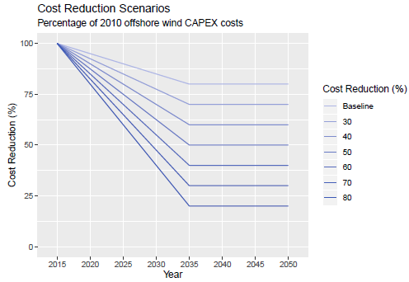

Carbon mitigation scenarios were constructed to linearly reduce emissions from 2010 to 2050 by percentage of 2010 electric sector CO2 emissions. 2010 emissions were calculated endogenously, using the TIMES model and EPAUS9rT database, calibrated to represent the current state of the US energy system in 2010. Each emissions reduction scenario instituted a constraint that held electric sector emissions to a cap, as represented by figure below. The baseline emissions reduction scenario assumed no carbon mitigation requirement. Each subsequent scenario increased the required carbon mitigation percentage by 10%, until an 80% carbon reduction is achieved by 2050.

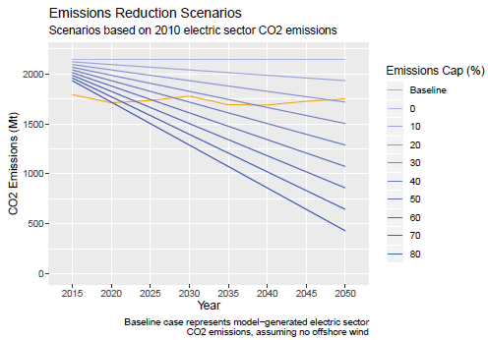

## Analysis and Discussion

The model was run 70 times, representing the combination of all 7 cost curves and all ten emissions caps. Offshore wind was not built out in all scenarios. Until the cost of offshore wind was reduced by 40%, it was not economically viable, even in the most stringent carbon mitigation scenarios. At a 40% cost reduction, less than 30 GW of offshore wind is built out by 2050. At 50% cost reduction, offshore wind is built out to approximately 18 times the capacity as that in the 40% scenario. As costs decrease to 60%, 70%, and 80%, the differences in the total capacity off offshore wind decrease and the overall total dramatically increases.

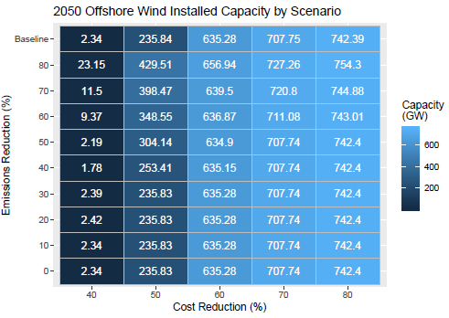

Offshore wind’s sensitivity to carbon mitigation stringency is well defined when the technology is more expensive and almost non-existent when the technology is less expensive. More stringent carbon mitigation incentivizes the buildout of offshore wind sooner, and at larger capacities, at the 40% and 50% reduction cost curves. For the 60%, 70%, and 80% reduction cost curves, carbon mitigation stringency influences when, but not by how much, offshore wind is installed.

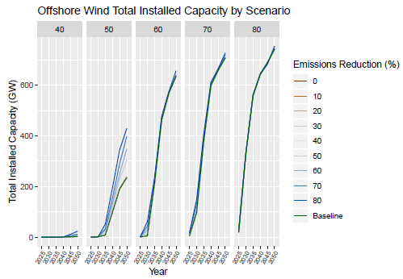

By looking at the annual installed capacity as opposed to the cumulative installed capacity, different trends emerge. We can see that the cost curves affect the speed at which offshore wind is deployed. The cheaper offshore wind becomes, the more capacity is built out each year, and the sooner that happens. We see in all scenarios, however, that offshore wind is built out in high quantities quickly and then capacity levels out. There is no scenario, other than the 40% cost curve, that elicits a slow or consistent buildout of offshore wind.

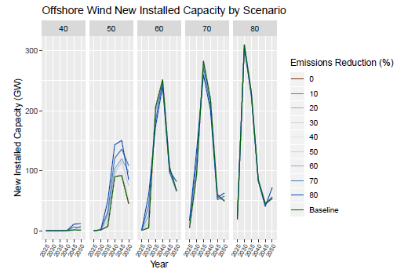

The deployment of offshore wind primarily displaces terrestrial wind, solar PV, coal, and natural gas. Below we can see that in the cases where offshore wind is cheapest, the total generation of that resources far outweighs that of any other resource. Additionally, the largest displacement is with natural gas. Natural gas makes up a large market share of the 2050 grid in all scenarios where offshore wind does not decrease in cost by more than 40%. Coal sees a similar displacement when offshore wind is built out, but the degree to which the cost scenarios affect its generation is less. While the cost of offshore wind elicits a decline in the production of all resources, we see that terrestrial wind, solar, and coal are more sensitive to carbon mitigation stringency.

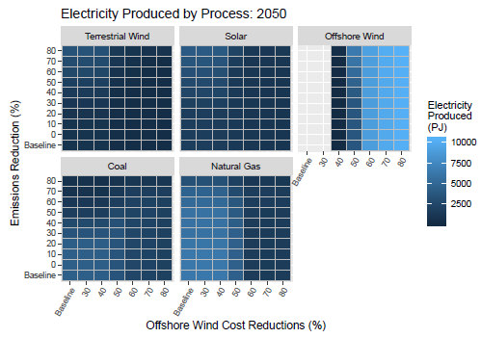

INCLUDE regional charts/discussion and the technology difference charts/discussion that we talked about.

All five of the electric sector emissions that we investigated ~~electric sector emissions~~ see an overall decline by 2050 in the baseline scenarios. However, we see a much steeper and quicker decline in these emissions with both increasing carbon mitigation stringency and decreasing cost of offshore wind. SO2 is most sensitive to emissions reductions while all other emissions are more sensitive to the deployment of offshore wind.

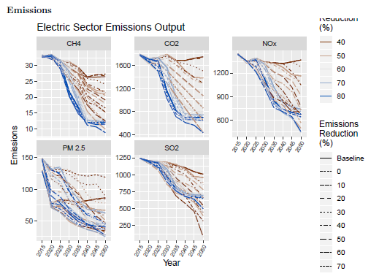

Assuming a moderate carbon mitigation stringency of 20%, offshore wind is able to elicit a steep decline of around 50% in CO2, NOx, and SO2 at a 60% cost reduction and above. At a 50% cost reduction there I still a 25% reduction in emissions by 2050. This shows that offshore wind deployment alone works as a strategy for electric sector grid emissions. The extent of the emissions reductions will, however, be proportional to the cost effectiveness of offshore wind.

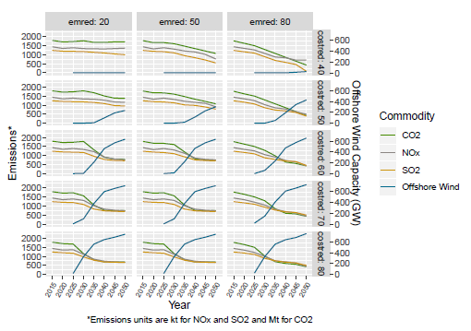

## Conclusions

## Notes on Modeling

1. <https://windeurope.org/about-wind/statistics/european/wind-energy-in-europe-in-2018/>
2. <https://www.nrel.gov/docs/fy16osti/66599.pdf>
3. <https://coast.noaa.gov/states/fast-facts/economics-and-demographics.html>
4. <https://s3.amazonaws.com/ncsolarcen-prod/wp-content/uploads/2019/07/RPS-CES-June2019.pdf>
5. <https://www.c2es.org/document/greenhouse-gas-emissions-targets/>
6. <https://www.eia.gov/tools/faqs/faq.php?id=427&t=4>
7. <https://www.eia.gov/energyexplained/?page=us_energy_home>
8. <https://www.greentechmedia.com/articles/read/offshore-wind-reaches-cost-competitiveness-without-subsidies#gs.op40g3>
9. <https://www.nrel.gov/docs/fy17osti/67675.pdf>
10. <https://www.ge.com/renewableenergy/wind-energy/offshore-wind/haliade-x-offshore-turbine>
11. <https://www.lazard.com/media/450784/lazards-levelized-cost-of-energy-version-120-vfinal.pdf>
12. <https://www.eia.gov/outlooks/aeo/pdf/electricity_generation.pdf>
13. <https://www.awea.org/Awea/media/About-AWEA/U-S-Offshore-Wind-Fact-Sheet-September-2018_2.pdf>
14. <https://www.greentechmedia.com/articles/read/breaking-rsted-wins-new-jerseys-first-offshore-wind-solicitation#gs.kmsg2u>
15. <https://www.awea.org/Awea/media/About-AWEA/U-S-Offshore-Wind-Fact-Sheet-September-2018_2.pdf>
16. <https://www.njspotlight.com/stories/19/06/18/big-question-for-offshore-wind-who-gets-power-to-the-customers/>
17. <https://iea-etsap.org/>
18. Hans-Kristian Ringkjøb, Peter M Haugan, Ida Marie Solbrekke**A review of modelling tools for energy and electricity systems with large shares of variable renewables**

    Renew Sustain Energy Rev, 96 (2018), pp. 440-459
19. Integrating short term variations of the power system into integrated energy system models: A methodological review
20. Loulou, R., Remme, U., Kanudia, A., Lehtilä, A. and Goldstein,G.: Documentation for the TIMES Model, Energy Technology Systems Ananlysis Programme (ETSAP), April 2005, (http://www.etsap.org/documentation.asp)